R1 Construction Ltd

Carbon Reporting and Reduction Plan

Current reporting year January to December 2025
(Baseline year April 2023 – March 2024)

Contents

1. Introduction 2
2. Scope 1, 2 and 3 Emissions Definitions 3
3. Carbon impact for the baseline year April 2023 to March 2024 4
3.1 Carbon emissions by source. 5
4. Carbon impact for the current reporting year Jan - Dec 2025 6
4.1 Carbon emissions by source. 7
5. Year-on-Year Comparison 8
5.1 Emissions by Source 8
5.2 Overall Carbon Intensity 8
5.3 Carbon Intensity by source 9
5. Carbon Reduction Commitments /Actions 10
6. Measurement 10
7. Prioritise 11
8. Action Plan 12
8.1 Communication 12
8.2 Road Fuel 12
8.3 Electricity 12
8.4 Construction Site energy use. 13
8.5 Staff Commuting 13
8.6 Site Waste 13
8.7 Supply Chain emissions 14
8.8 Summary of Short Term Actions (by end 2025) 14
9. Carbon Reduction Trajectory 15
10. Audit 16
11. Offsetting 16
12. Declaration 17

Introduction

R 1 Construction Ltd has committed to reducing the carbon emissions from our own operations to Net Zero by 2045 at the latest, and across our supply chain by 2050, using as far as possible direct reduction, and offsetting the remainder.

We do this because we are conscious of the environmental, social and economic imperative to act on climate change.

The UK Government amended the Climate Change Act 2008 in 2019 by introducing a target of at least 100% reduction in the net UK carbon account (i.e. a reduction of greenhouse gas emissions when compared to 1990 levels) by 2050. As a result, Central Government Departments, their Executive Agencies and Non-Departmental Public Bodies are required to ensure that suppliers to contracts with an annual value of in excess of £5 million (excluding VAT) per year are committed to achieving “Net Zero by 2050” for all procurements after 30th September 2021.

This has led to PPN 06/21 which applies to all new procurements from this date and this includes framework call-offs and Dynamic Purchasing Systems where the anticipated individual value of the call-off or DPS is £5 million (excluding VAT) per annum or more. To demonstrate compliance, we have set out our environmental management measures in our Carbon Reduction Plan which includes:

- Confirming our commitment to achieving Net Zero by 2045 for our operations.
- Details of our carbon footprint/current emissions for the sources included in Scope 1 and 2 of the GHG Protocol and a defined subset of Scope 3 emissions.
- Providing emissions reporting of the CO2e (Carbon Dioxide Equivalent) for the greenhouse gases covered by the Kyoto Protocol (predominantly carbon dioxide, methane and nitrous oxide).
- Setting out the environmental management measures we have adopted including specific carbon reduction measures.
- Publication of our Carbon Reduction Plan on our website.

Scope 1, 2 and 3 Emissions Definitions

Scope 1 Direct Emissions - these are direct greenhouse gas emissions that occur from sources that are controlled or owned by us (e.g. emissions from boilers, vehicles etc).

Scope 2 Energy Indirect Emissions - these are indirect greenhouse gas emissions associated from the purchase of electricity, heating or cooling and are measured and reported in alignment with our energy use.

Scope 3 Other Indirect Emissions - these fall into 15 categories and include all sources not specified within Scopes 1 and 2 above. The Scope 3 emissions that we are required to report on are:

- “Upstream” transportation and distribution of products purchased by us from Tier 1 suppliers (e.g. paper, computers, office consumables).
- Disposal and treatment of waste generated in facilities not owned or controlled by us.
- Transportation of employees for business related activities in vehicles not owned or operated by us.
- Transportation of employees between home and work in vehicles not owned or operated by us including in their own vehicles.
- “Downstream” transportation and distribution of products sold by us including retail and storage.

We have exceeded the minimum requirement for Scope 3 emission reporting, by also including:

- The emissions from all major materials used in the construction of our buildings,
- Emissions resulting from capital asset purchased,

Carbon impact for the baseline year April 2023 to March 2024

The tables below show our carbon footprint in our baseline year April 2023 to March 2024 when we first started measuring our emissions.

Baseline Year: | Apr 23-Mar 24
Baseline Emissions Calculations: | All Scopes – tonnes CO2e/ year
Scope 1 CO2e: | 101.73
Scope 2 CO2e: | 8.50
Scope 3 CO2e (all sources): | 3710.24
Total Emissions: | 3820.47

3.1 Carbon emissions by source.

 | 23-24
Emission Source | Tonnes CO2
Electricity | 8.500
Liquid Fuel - plant and generators | 27.400
Liquid Fuel - road vehicles | 74.330
Staff Commuting | 75.600
Employee Owned business travel | 0.290
Construction Materials and contractors | 3440.040
Office Consumables | 0.396
Office waste | 0.033
Site Waste | 159.670
Assets | 34.215
TOTAL | 3820.474

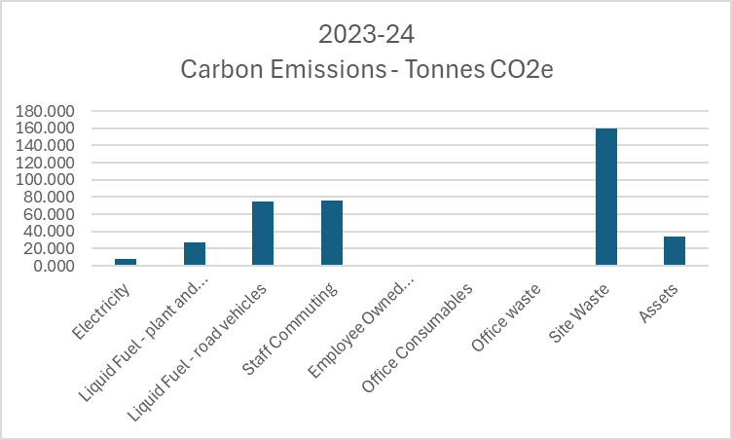
*Graph excludes Materials due to scale.

Carbon impact for the current reporting year Jan - Dec 2025

The tables below show our carbon footprint in our current reporting year, 2025.

We have changed our reporting period to Calander year, so acknowledge that there is a gap in reporting data between April 2024 and January 2025.

Current Year: | 2025
Baseline Emissions Calculations: | All Scopes – tonnes CO2e/ year
Scope 1 CO2e: | 109.50
Scope 2 CO2e: | 10.98
Scope 3 CO2e (all sources): | 4471.00
Total Emissions: | 4591.48

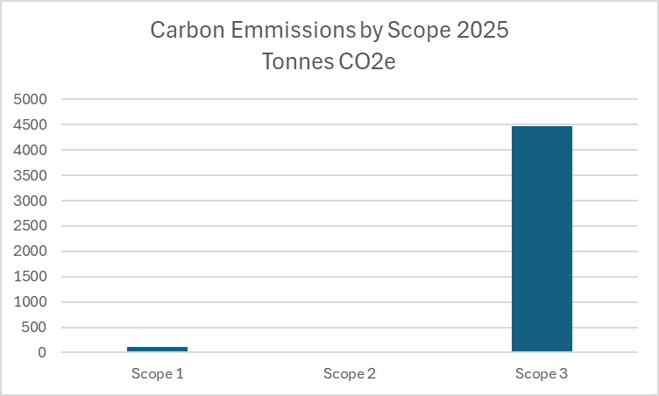

4.1 Carbon emissions by source.

 | 2025
Emission Source | Tonnes CO2
Electricity | 32.58
Liquid Fuel - plant and generators | 76.92
Liquid Fuel - road vehicles | 10.98
Staff Commuting | 22.67
Employee Owned business travel | 0.00
Construction Materials and contractors | 4066.05
Office Consumables | 0.13
Office waste | 1.73
Site Waste | 311.83
Assets | 68.58
TOTAL | 4591.49

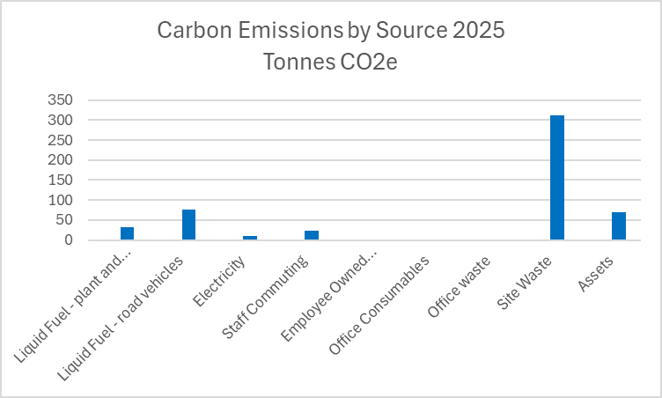
*Graph excludes Materials due to scale.

Year-on-Year Comparison

5.1 Emissions by Source

Tonnes CO2 | 23-24 | 2025 | Tonnes Difference
Liquid Fuel - plant and generators | 27.40 | 32.58 | 5.18
Liquid Fuel - road vehicles | 74.33 | 76.92 | 2.59
Electricity | 8.50 | 10.98 | 2.48
Staff Commuting | 27.60 | 22.67 | -4.93
Employee Owned business travel | 0.29 | 0.00 | -0.29
Construction Materials and contractors | 3,440.04 | 4,066.05 | 626.01
Office Consumables | 0.40 | 0.13 | -0.26
Office waste | 0.03 | 1.73 | 1.70
Site Waste | 159.67 | 311.83 | 152.16
Assets | 34.22 | 68.58 | 34.36
TOTAL | 3,820.47 | 4,591.49 | 771.01

5.2 Overall Carbon Intensity

Carbon Intensity | 2023/24 | 2025
Tonnes per £m turnover | 387.08 | 430.54

5.3 Carbon Intensity by source

Emission Source | Tonnes CO2 per £1m turnover
 | 23/24 | 2025
Liquid Fuel - plant and generators | 2.78 | 3.06
Liquid Fuel - road vehicles | 7.53 | 7.21
Electricity | 0.86 | 1.03
Staff Commuting | 7.66 | 2.13
Employee Owned business travel | 0.03 | 0.00
Construction Materials and contractors | 348.53 | 381.27
Office Consumables | 0.04 | 0.01
Office waste | 0.00 | 0.16
Site Waste | 16.18 | 29.24
Assets | 3.47 | 6.43
TOTAL | 387.08 | 430.54

Carbon Reduction Commitments /Actions
R 1 Construction is committed to achieving Net Zero within its own operations by 2045 and as part of this commitment, has an interim targets of reducing emissions by 2025, 2030, 2035 and 2040. This plan is reviewed annually by the Directors to check progress and establish if changes should be made to the actions we have in place to maximise our reduction in carbon emissions.

The basis of our Carbon strategy is one of Measure – Prioritise – Act – Measure – Repeat.

Measurement
We report on the sources of environmental impact over which we have operational control and calculate our carbon footprint monthly, in accordance with the Greenhouse Gas (GHG) Protocols Corporate Standard and report against the Kyoto Protocol greenhouse gasses in terms of:

- Actual targets – absolute reduction targets which compare actual figures in the target year to those in the base year.
- Intensity targets – based on a normalising factor.

We subscribe to a third party service to manage our data inputs, conduct the required calculations, set and record our intensity metrics, and provide monthly carbon reporting. The data that sits behind this is the UK Government Greenhouse Gas reporting database, updated when appropriate.

This provides us with our emissions by source, and total emissions by month, sets our intensity metrics and shows how we are tracking month-on-month.

Our chosen intensity metrics are tonnes /CO₂ per £1m turnover.

Our baseline year for all measurements is April 23 to March 24. We have subsequently changed our reporting period to Calander year and acknowledge that this has created a gap in reporting data.

Specific inputs and output used to calculate figures quoted in our Carbon Reduction Plan include:

- Electricity
- Liquid Fuel - plant and generators
- Liquid Fuel - road vehicles
- Staff Commuting
- Employee Owned business travel
- Construction Materials and contractors
- Office Consumables
- Office waste
- Site Waste
- Assets (Depreciation during the reporting period)

Conversion Factors

The conversion factors used throughout are the ‘2025 UK Government Greenhouse Gas Conversion Factors for Company Reporting and DEFRA ‘Table 13’ Indirect Emissions for the Supply Chain emissions.

Prioritise
Our monthly carbon calculation has enabled us to identify the largest sources of GHG emissions, and to focus our areas of impact. That does not imply however that we are not implementing actions across the board. We have been able to identify quick and easy wins which relate to relatively low impact areas whilst also implementing longer term multi-facet strategies for the larger emission areas.

Action Plan

8.1 Communication

We have successfully communicated our Net Zero ambitions across our workforce, and have formed an employee task force. This task force is charged with identifying where our staff can affect carbon reductions through behaviour change.

We will report our carbon emissions and progress against target to our employees monthly, via a display at both our offices.

We have developed a communication plan which describes our ambitions and commitments to our key customers and suppliers, and in our general communications.

8.2 Road Fuel

This is by far our largest contributor, and it arises from our fleet of passenger cars and commercial vehicles.

- UK legislation phases out fossil fuelled vehicles in favour of alternative fuelled vehicles such as electric battery vehicles, by 2035. We will work at an accelerated pace however to include BEVs into our fleet well ahead of this 2030 target, as detailed in our Carbon Reduction Trajectory (Section 10).
- As an interim measure, we will run trials on diesel fuel consumption technology, both fuel additives and technology bolt-on’s, and fully assess the results, rolling out if appropriate.

8.3 Electricity

Electricity whilst not one of our highest sources of carbon emissions, it is a significant operating cost and does have a carbon emissions associated with it.

We do not own the building that we occupy, so the option for installing technology such as Solar PV is not open to us. We will however attempt to persuade the building owners to consider it.

The building is of modern construction, with air source heat pumps providing heating, and with modern light fittings and controls.

8.4 Construction Site energy use.

At some construction sites, we rely on the use of diesel generators for temporary power, prior to network connection.

We are already seeking lower carbon alternative solutions, have have identified temporary power solutions under development that use solar PV and small wind turbines combined with battery storage. We will roll out these solutions as they become available to us.

As an interim measure, we will investigate the cost and availability of HVO (Biodiesel) as a fossil diesel replacement.

8.5 Staff Commuting

We have used the same EV replacement trajectory to reflect reduction in emissions from staff commuting. We will facilitate the adoption of EV by our staff by providing further charge points at our premises.

We will also encourage active travel by adopting and promoting the Cyle-to-Work scheme, a tax incentive for employees to purchase bicycles.

8.6 Site Waste

This is a significant area of carbon emission for us. Whilst we are not in direct control of how our site waste is disposed, we can and will request information from our contractors, and use that information to inform supplier contracts.

We will continue to strive for 100% on-site waste separation according to material type and disposal options.

8.7 Supply Chain emissions

In common with most businesses, our supply chain, Scope 3, emissions make up the majority, and also in common with most businesses, these are the hardest to abate.

We are developing a strategy specifically to understand and address these emissions. For us, these result primarily from the materials used in the buildings we construct – timber, aggregates, metal, plus the myriad other materials.

Our approach will be to first research how each industry involved in our supply chain is approaching decarbonisation. We will research which actors in each segment are making the most rapid and ambitious progress, and focus our procurement decisions accordingly.

8.8 Summary of Short Term Actions (by end 2025)

- Begin to introduce EVs into our vehicle fleet
- Conduct an in-depth analysis of our site waste generation and disposal
- Install at least one additional EV charge point at our office
- Conduct full material supply chain analysis
- Trial the use of diesel fuel additives
- Trial the use of HVO(Biodiesel) in site generators.

Carbon Reduction Trajectory

We have set emission reduction target by source as percentage reductions against the baseline year for 2030, 2035, 2040, and 2045 as achieving Net Zero within our Scope 1 and 2 emissions, and some limited Scope 3 emissions.

 | Tonnes CO2
 | 23-24 | 2030 | 2035 | 2040 | 2045
Electricity | 8.50 | 7.65 | 6.80 | 4.25 | 0.00
Liquid Fuel - plant and generators | 27.40 | 21.92 | 13.70 | 5.48 | 0.00
Liquid Fuel - road vehicles | 74.33 | 59.46 | 37.17 | 14.87 | 0.00
Staff Commuting | 75.60 | 60.48 | 37.80 | 15.12 | 0.00
Employee Owned business travel | 0.29 | 0.23 | 0.15 | 0.06 | 0.00

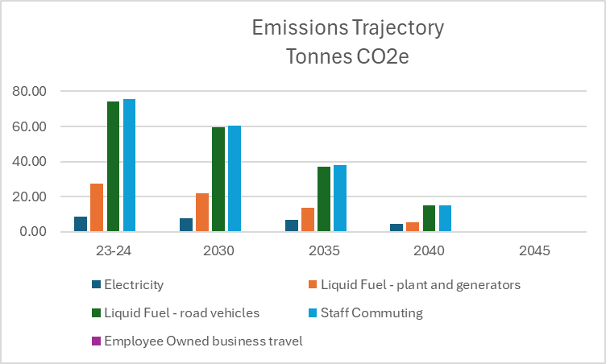

We have not projected the emissions trajectory for those areas where we have no direct control (other than purchasing decisions). However, as our de-carbonisation process develops, we will do so.

Audit
Whilst not compulsory, we have committed to an annual audit of our carbon data reporting, by an independent third party.

Offsetting
Offsetting the emissions that we can’t mitigate will become part of our strategy, but only at the point that we’ve implemented all of the possible behavioural, process and technology changes.

Carbon offsetting is an unregulated market, and has suffered some negative publicity due to exaggerated claims on carbon savings. We also note that the UK market has little capacity at present.

We will take expert guidance to identify a credible and verifiable carbon offsetting scheme, that nay be UK or Overseas based.

Declaration
This Carbon Reduction Plan has been completed in accordance with PPN 06/21 and associated guidance.

Emissions have been reported and recorded in accordance with the published reporting standard for Carbon Reduction Plans, the GHG Reporting Protocol Corporate Standard and we use the appropriate Government emission conversion factors for greenhouse gas company reporting.

Scope 1 and Scope 2 emissions have been reported in accordance with SECR requirements and the required subset of Scope 3 emissions have been reported in accordance with the published reporting standard for Carbon Reduction Plans and the Corporate Value Chain (Scope 3) Standard.

We confirm this Carbon Reduction Plan is reviewed and signed off at board level on an annual basis and is available on the home page of our website.

Signature:

Name:

Job Title/Designation (must be a director or equivalent):

Date:

------------------------------------------------------------

